Day in the Life of the Hudson River 10/13/22
Rt 28N Bridge & Arbutus Lake Outlet, Newcomb
RIVER MILE: 300 & 305
Above the Salt front in the upper Hudson
DITL Runner– Doug Reed
1 adult
Latitude °N & Longitude – °W
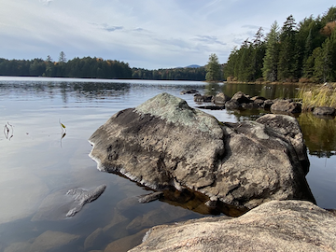 | 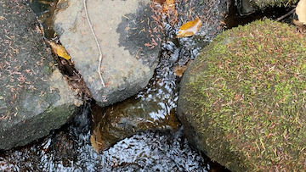 | 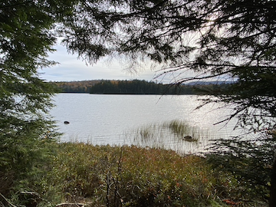

Location: Rt 28N Bridge & Arbutus Lake Outlet, Newcomb, NY
Description: Arbutus Lake and the western tributary Archer Creek is the uppermost Hudson River site visited on Wed. Oct 12th (the day before the Day in the Life of the Hudson River Oct 13, 2022.) Arbutus Lake and its forested watershed have been the focus of long-term ecosystem monitoring since 1978.

*NR = Not read/recorded
ITEM |  | Time |  | Reading |  |  |  | Comments
Physical
Air Temperature- |  | 12:25 PM  2:00 PM  3:01 PM  5:07 PM |  | 18.3°C  18.3°C  17.2°C  17.2°C |  |  | 65°F  65°F  63°F  63°F
Wind Speed: NR |  |  |  | Anemometer |  |  | Beaufort | Direction
Weather today |  | 12:25 PM  2:00 PM  3:01 PM  5:07 PM |  | < 25% cloud cover  < 25% cloud cover  51-75% cloud cover  >75% cloud cover |  |  | No Rain  No Rain  No Rain  No Rain
Weather the past 3 days: |  | Clear and dry
Tides- N/A |  | Time |  | Rising, Falling, Unchanged |  |  | Water Height (cm)
Current- |  | Time |  | Ft³/s |  | Knots | North/South | Ebb/Flood/Still
*USGS North Creek stream gage |  | 7:15 AM  2:00 PM |  | 511  72.6
Water Temperature- |  | 12:25 PM  2:23 PM  NR |  | 9.7°C  9.7°C  12.5°C |  |  | 49.5°F  49.5°F  54.3°F
Turbidity- NR
Chemical
Salinity-NA
Standardized Salinity – LR Quantab |  | 12:25 PM  2:50 PM |  | BD  BD |  |  | BD: Below Detection
DO – Lamotte Drop Count Kit |  | Time  2:30 PM |  | Temp  9.7°C |  |  | ppm DO  9.2 ppm | % saturation  NR
pH – Color Match Kit |  | 2:23 PM |  | 6.6
Nitrates- NR
Phosphates- NR
Alkalinity- NR
Biological- Did Not Seine
Fish – |  | Number |  | Name |  |  | Length of longest | Length of smallest
Fish Totals |  | TOTAL: |  | Diversity:
Macroinvertebrates |  | Number |  | Name |  |  | Length of longest | Length of smallest
Macroinvertebrate Totals |  | TOTAL: |  | Diversity:
Sediment Core – NR
Length | H2S smell |  | Oxid Top |  | Oil |  | Grain Size | Other Features
Boats- NR
 | Time |  | Name |  | Color |  | North/Southbound | Light/Loaded
Commercial
Recreational

